CRIMINAL INVESTIGATION DEPARTMENT SB KATHUA

No. CID/DYSPK/973
Dated: - 11-04-2026
The Sr. Supdt. of Police,
CID-SB Jammu.

Subject: - Assessment report regarding visit of New Head of Radha Swami Satsang Beas, Amritsar, Sh. Jasdeep Singh Gill at Kali Bari, Kathua

Sir,
In reference to the subject cited above, in this regard as per the report of SO CID SB Kathua, it is submitted that on 12.05.2026, The New Head of Radha Swami Satsang Beas, Amritsar, Sh. Jasdeep Singh Gill commonly known as Hazoor Ji will visit Radha Swami Satsang Ghar, Near SK Farms, Kali Bari, Kathua.

Assembly area/Venue
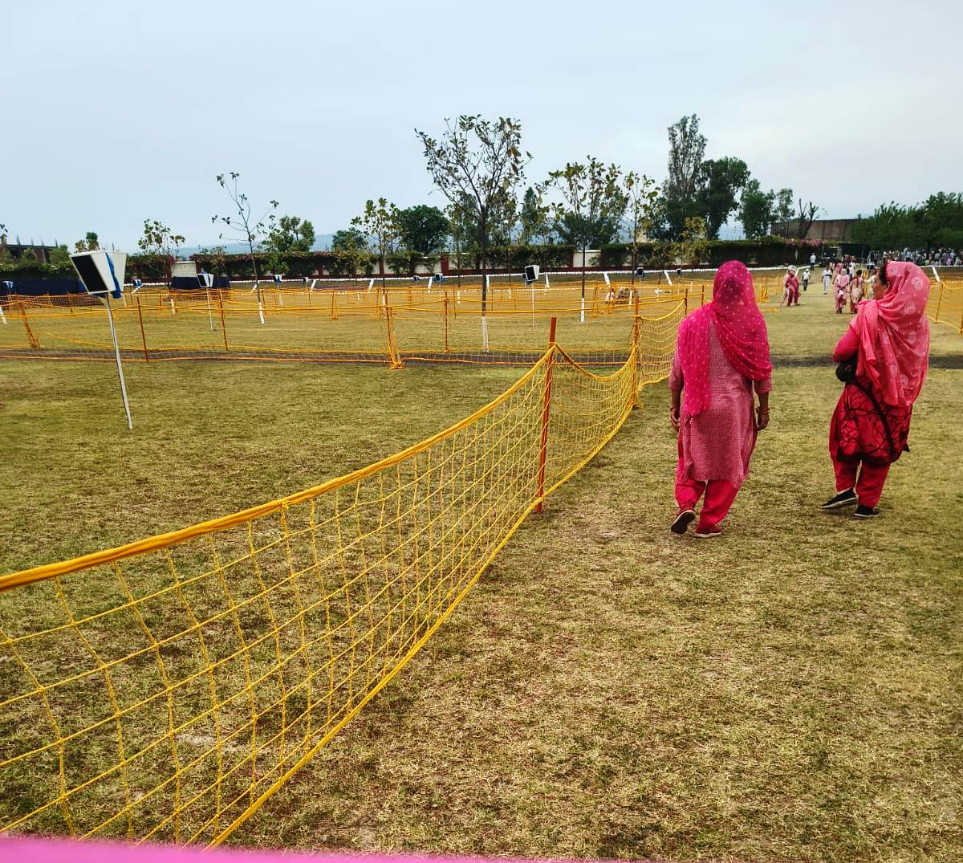

Parking Area
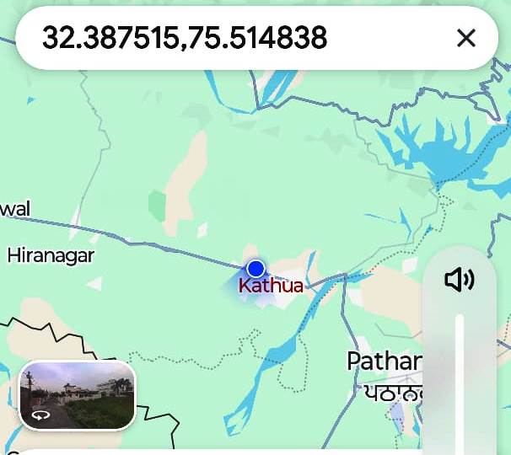
- General Location Overview:-The said Satsang Ghar comprises of 10 acre of land surrounded in North & East side by the boundary of Indian Army(Rocket Regiment), Janglote. In the west side the parking area has been earmarked on the bank of nallah (Sahar Khad) which is an open area. In the south, it is surrounded by 02 marriage palaces (SK Farms & MR Resorts) two private schools (Kidzee & Indian Public School) and one private college (Sh. Rajeev Gandhi College). Apart from these institutions, significant number of residential buildings has been constructed including almost Hindu population. There are 03 entry gates; No.01 Gate (East Side) is meant for pick & drop gate for Sangat, No.02 (Middle Gate) is meant for sangat on foot only whereas Gate No.03 (West Side) is meant for bikes LMVs and HMVs.

- Helipad Area: The helipad site is located within the premises Satsang Ghar which has constructed much earlier by using cemented tiles.
- Venue Details (Radha Swami Satsang Ghar, Kali Bari):-The proposed venue is Radha Swami Satsang Ghar, Kali Bari Surrounded by Army Boundary in the North, Marriage Palaces & Private Education Institutions in the South, Satsang Shed in the East and Parking area plus Sahar Khad in the west side. No residential building falls within the 100 meter diameter of Helipad.
The distance between Helipad to Venue is 100 meters only that is too within the boundary of Satsang Ghar.
4. Organisers:-
- Sardar Manjit Singh (Area Secretary) M.No.7889695151
- Sh. Vijay Choudhary @ Vicky (Secretary Satsang Ghar Kalibari Kathua) M.No.9906038469

Hence submitted.
Yours faithfully,

Sd/-
Dy. Supdt. of Police,
CID-SB, Kathua.

